Deliverable Set #1

The study area block begins on Torresdale Ave. and Shelmire Ave. and is located right next to the Holmesburg station on SEPTA’s regional rail line. The neighborhood is Mayfair in north east Philadelphia, and the GSI planning district for the CSO service area is North Delaware. The block dips towards south east, draining into a storm drain in this corner. This stormwater then drains to an outfall on the right bank of the lower Pennypack Creek, which I suspect may overflow during intense rain events. The block has three sets of homes, and the entire patio area between has been paved over for parking spaces. I pass this block almost everyday on my train ride in and have noted that just south of it there is a massive concrete pit that fills with water and only drains by evaporation. Otherwise, the whole area is a giant impervious surface. I am focusing on the neighborhood but am also interested in this extra location’s ability to store water, and wanted to be able to come back to this model later to explore this.

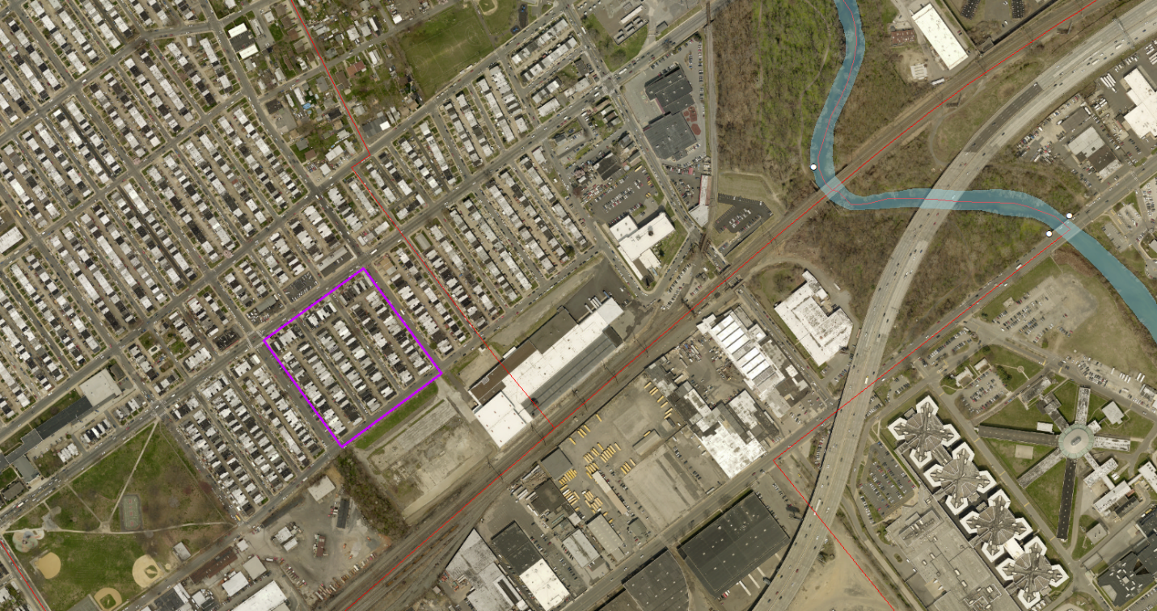

To set up the area for analysis in SWMM, the aerial image was loaded into the program to scale (used a projection file or World Coordinates File). This way all the planimetry could be done within SWMM. I split each of the three rows of houses on the block into its own sub catchment, with a sub catchment of road in-between. I used the measurement tool to get the areas of the roofs and lawns. The three catchments with homes are uniform, each with 43.5% roof, 10.9% law/garden, leaving the other 45.7% to sidewalks, patio and driveway. The flow length was determined from the end of a plot to the center of the road to be 90 ft for catchments with houses. For the roads I used a 20 ft length, a little more generous than the figure for the midterm. For the grass plot 500 ft was used as this is all pervious natural area. Manning’s N for impervious surfaces followed that of smooth concrete (0.012) and was assumed for roofs too as these are also a smooth material. For pervious areas this was set to 0.13 for a natural range. Depression storage for impervious is 0.05 as this is the low end for a normal range, and 0.10 for pervious as this is the low end for that normal range. I used the Modified Green-Ampt infiltration model, using sandy loam the suction head is 4.33 with a conductivity of 0.43. I measured elevation drops of just under 2 ft per 200 ft distance, and so all sub catchments were given a 1% slope.

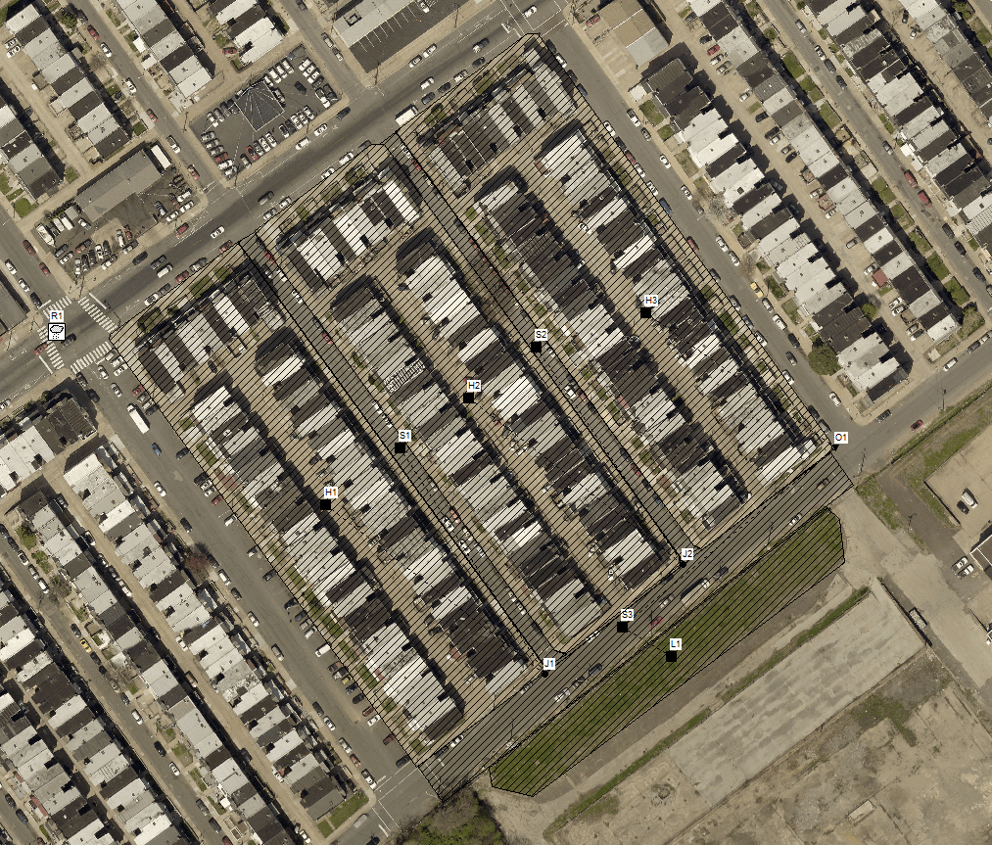

|  |  |  |
| --- | --- | --- |
| House Subcatchments | | |
| Area | 2.17 |  |
| Width | 1050.3 | L = 90 ft |
| % Slope | 1.0 | Elevation measurements |
| % Imp | 89.1 | As measured (Roof + sidewalk + patio + driveway) |
| N-Imperv | 0.012 | Smooth concrete |
| N-Perv | 0.130 | Natural range |
| DS-Imperv | 0.05 | Low-end average |
| DS-Perv | 0.10 | Low-end average |
| %0-Imp | 25 | Representative valus |
| SubAR | Outlet | Outlet |
| Suction | 4.33 | Sandy Loam |
| K | 0.43 | Sandy Loam |

|  |  |  |
| --- | --- | --- |
| Road Subcatchments | | |
| Area | 0.24 |  |
| Width | 522.7 | L = 20 ft |
| % Slope | 1.0 | Elevation measurements |
| % Imp | 100.0 | All road |
| N-Imperv | 0.012 | Smooth concrete |
| N-Perv | 0.130 | Natural range |
| DS-Imperv | 0.05 | Low-end average |
| DS-Perv | 0.10 | Low-end average |
| %0-Imp | 25 | Representative valus |
| SubAR | Outlet | Outlet |
| Suction | 4.33 | Sandy Loam |
| K | 0.43 | Sandy Loam |

|  |  |  |
| --- | --- | --- |
| Grass Subcatchment | | |
| Area | 0.56 |  |
| Width | 50.0 | L = 500 ft |
| % Slope | 0.5 | Elevation measurements |
| % Imp | 0.0 | No impervious |
| N-Imperv | 0.012 | Smooth concrete |
| N-Perv | 0.130 | Natural range |
| DS-Imperv | 0.05 | Low-end average |
| DS-Perv | 0.10 | Low-end average |
| %0-Imp | 25 | Representative values |
| SubAR | Outlet | Outlet |
| Suction | 4.33 | Sandy Loam |
| K | 0.43 | Sandy Loam |

**CONTINUOUS MODEL RUN**

EPA STORM WATER MANAGEMENT MODEL - VERSION 5.1 (Build 5.1.013)

--------------------------------------------------------------

*********************************************************

NOTE: The summary statistics displayed in this report are

based on results found at every computational time step,

not just on results from each reporting time step.

*********************************************************

****************

Analysis Options

****************

Flow Units ............... CFS

Process Models:

Rainfall/Runoff ........ YES

RDII ................... NO

Snowmelt ............... NO

Groundwater ............ NO

Flow Routing ........... YES

Ponding Allowed ........ YES

Water Quality .......... NO

Infiltration Method ...... MODIFIED_GREEN_AMPT

Flow Routing Method ...... DYNWAVE

Surcharge Method ......... EXTRAN

Starting Date ............ 01/01/2014 00:00:00

Ending Date .............. 12/31/2014 23:00:00

Antecedent Dry Days ...... 0.0

Report Time Step ......... 00:01:00

Wet Time Step ............ 00:01:00

Dry Time Step ............ 01:00:00

Routing Time Step ........ 15.00 sec

Variable Time Step ....... YES

Maximum Trials ........... 8

Number of Threads ........ 1

Head Tolerance ........... 0.005000 ft

************************** Volume Depth

Runoff Quantity Continuity acre-feet inches

************************** --------- -------

Total Precipitation ...... 29.600 43.960

Evaporation Loss ......... 3.891 5.779

Infiltration Loss ........ 4.652 6.909

Surface Runoff ........... 21.060 31.277

Final Storage ............ 0.000 0.000

Continuity Error (%) ..... -0.012

************************** Volume Volume

Flow Routing Continuity acre-feet 10^6 gal

************************** --------- ---------

Dry Weather Inflow ....... 0.000 0.000

Wet Weather Inflow ....... 21.060 6.863

Groundwater Inflow ....... 0.000 0.000

RDII Inflow .............. 0.000 0.000

External Inflow .......... 0.000 0.000

External Outflow ......... 20.943 6.825

Flooding Loss ............ 0.118 0.039

Evaporation Loss ......... 0.000 0.000

Exfiltration Loss ........ 0.000 0.000

Initial Stored Volume .... 0.000 0.000

Final Stored Volume ...... 0.000 0.000

Continuity Error (%) ..... -0.009

***************************

Time-Step Critical Elements

***************************

None

********************************

Highest Flow Instability Indexes

********************************

All links are stable.

*************************

Routing Time Step Summary

*************************

Minimum Time Step : 2.00 sec

Average Time Step : 15.00 sec

Maximum Time Step : 15.00 sec

Percent in Steady State : 0.00

Average Iterations per Step : 2.00

Percent Not Converging : 0.00

***************************

Analysis begun on: Wed Mar 20 21:17:29 2019

Analysis ended on: Wed Mar 20 21:17:35 2019

Total elapsed time: 00:00:06

**EVENT BASED SIMULATION**

EPA STORM WATER MANAGEMENT MODEL - VERSION 5.1 (Build 5.1.013)

--------------------------------------------------------------

*********************************************************

NOTE: The summary statistics displayed in this report are

based on results found at every computational time step,

not just on results from each reporting time step.

*********************************************************

****************

Analysis Options

****************

Flow Units ............... CFS

Process Models:

Rainfall/Runoff ........ YES

RDII ................... NO

Snowmelt ............... NO

Groundwater ............ NO

Flow Routing ........... YES

Ponding Allowed ........ YES

Water Quality .......... NO

Infiltration Method ...... MODIFIED_GREEN_AMPT

Flow Routing Method ...... DYNWAVE

Surcharge Method ......... EXTRAN

Starting Date ............ 01/01/2014 00:00:00

Ending Date .............. 01/01/2014 06:00:00

Antecedent Dry Days ...... 0.0

Report Time Step ......... 00:01:00

Wet Time Step ............ 00:01:00

Dry Time Step ............ 01:00:00

Routing Time Step ........ 15.00 sec

Variable Time Step ....... YES

Maximum Trials ........... 8

Number of Threads ........ 1

Head Tolerance ........... 0.005000 ft

************************** Volume Depth

Runoff Quantity Continuity acre-feet inches

************************** --------- -------

Total Precipitation ...... 1.764 2.620

Evaporation Loss ......... 0.009 0.014

Infiltration Loss ........ 0.188 0.279

Surface Runoff ........... 1.551 2.304

Final Storage ............ 0.018 0.026

Continuity Error (%) ..... -0.098

************************** Volume Volume

Flow Routing Continuity acre-feet 10^6 gal

************************** --------- ---------

Dry Weather Inflow ....... 0.000 0.000

Wet Weather Inflow ....... 1.552 0.506

Groundwater Inflow ....... 0.000 0.000

RDII Inflow .............. 0.000 0.000

External Inflow .......... 0.000 0.000

External Outflow ......... 1.031 0.336

Flooding Loss ............ 0.521 0.170

Evaporation Loss ......... 0.000 0.000

Exfiltration Loss ........ 0.000 0.000

Initial Stored Volume .... 0.000 0.000

Final Stored Volume ...... 0.000 0.000

Continuity Error (%) ..... 0.009

***************************

Time-Step Critical Elements

***************************

Link C2 (15.58%)

********************************

Highest Flow Instability Indexes

********************************

All links are stable.

*************************

Routing Time Step Summary

*************************

Minimum Time Step : 3.57 sec

Average Time Step : 14.63 sec

Maximum Time Step : 15.00 sec

Percent in Steady State : -0.00

Average Iterations per Step : 2.02

Percent Not Converging : 0.07

***************************

Analysis begun on: Wed Mar 20 21:30:32 2019

Analysis ended on: Wed Mar 20 21:30:32 2019

Total elapsed time: < 1 sec

Deliverable Set #2

The issue with this block is the sheer amount of impervious surfaces. The area between homes was converted to pavement and each house was given a garage here. It is not feasible to take away garages and install a nice vegetated strip or rain garden here. Instead the area will receive permeable pavement, to increase infiltration and retention time. Additional LID controls to supplement this plan could be downspout connections and rain barrels, or a rain garden in where the grassy area lies. The LID control will go in, and then will drain the back patios and driveways but not the roof tops.

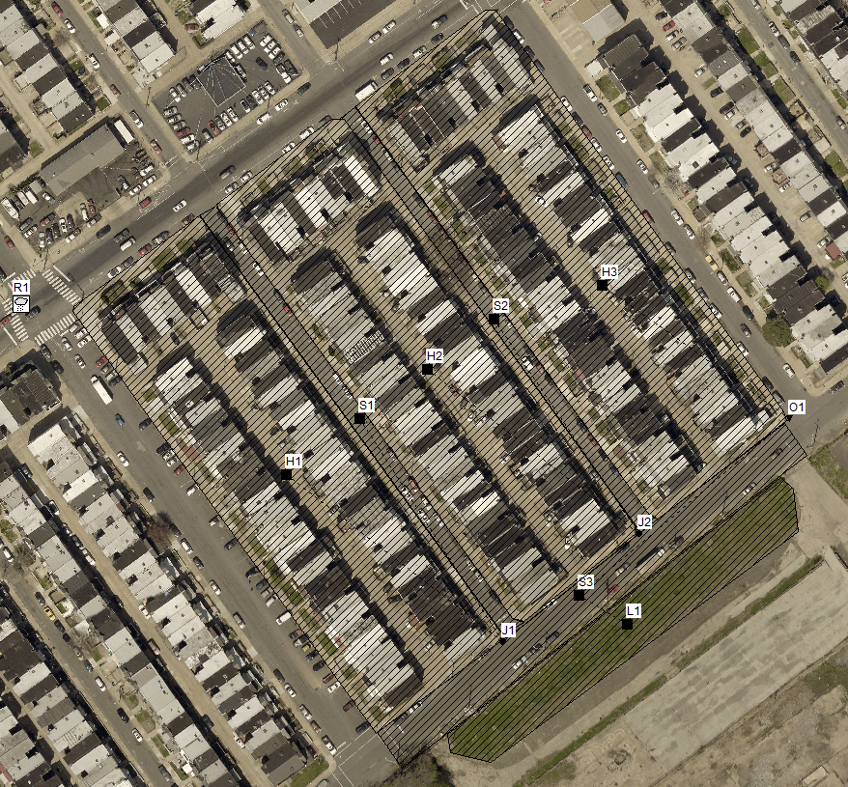

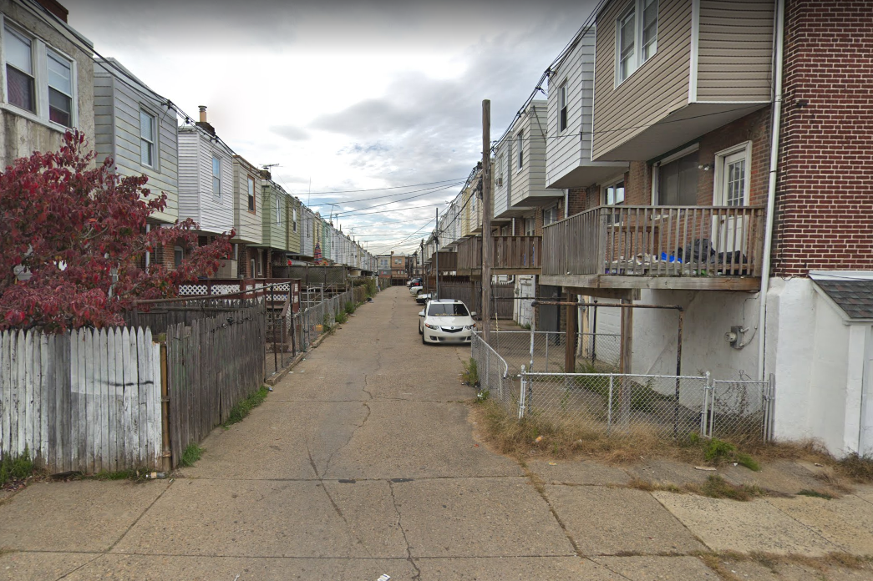

440 ft

13 ft

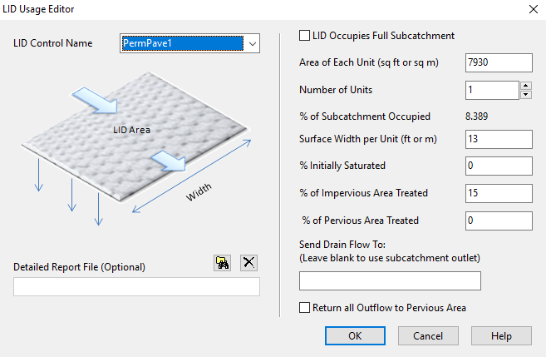

|  |  |  |
| --- | --- | --- |
| Surface | | |
| Berm Height (in) | 0.0 | No berm |
| Veg. Volume Fraction | 0.0 | No vegetation |
| Roughness (n) | 0.014 | Slightly higher than smooth concrete |
| Slope | 1.0 | Same as before |

|  |  |  |
| --- | --- | --- |
| Pavement | | |
| Thickness (in) | 4.0 | Low end, want it to move quickly to storage and will not clog as fast |
| Void Ratio | 0.21 | High end, want better transmission to storage |
| Imp Surf Fraction | 0.0 | Continuous porous pavement |
| Permeability | 200 | "Infiltration rates are generally hundreds of inches per hour. Even as pavements clog with time, infiltration rates remain above 1 inch per hour, sufficient for most stormwater events" EPA Manual |
| Clogging Factor | 320 | Yclog * Pa * CR * (1 + VR) * (1 - ISF) / (T * VR). 5 years to clog a continuous porous pavement system that serves an area where the annual rainfall is 44 inches/year. If the pavement is 4 inches thick, has a void ratio of 0.21 and captures runoff only from its own surface, then the Clogging Factor is 5 x 44 x (1 + 0.21) / 4 / 0.21 = 320 |
| Regeneration Interval (days) | 365 | Vacuumed once a year |
| Regeneration Fraction | 0.5 | Restored to half original permeability value |

|  |  |  |
| --- | --- | --- |
| Soil | | |
| Thickness (in) | 18 | Not too much, want the storage but may limit infiltration |
| Porosity | 0.437 | Sand (Manual) |
| Field Capacity | 0.062 | Sand (Manual) |
| Wilting Point | 0.024 | Sand (Manual) |
| Conductivity (in/hr) | 4.74 | Sand (Manual) |
| Cond. Slope | 30 | 30-60 is typical for sand-clay (Manual) |
| Suction Head (in) | 1.93 | Sand (Manual) |

|  |  |  |
| --- | --- | --- |
| Storage | | |
| Thickness (in) | 24 | Pretty thick, no groundwater worries so have space |
| Void Ratio | 0.75 | High end for a gravel bed |
| Seepage Rate (in/hr) | 0.43 | Sandy loam in catchment |
| Clogging factor | 0 | Ignore clogging in this layer |

|  |  |  |
| --- | --- | --- |
| Drain | | |
| Flow Coefficient | 1.0 | Drain coefficient to 2D^(1/2)/T where D is the distance from the drain to the surface plus any berm height (in inches or mm) and T is the time in hours to drain. 2*36^(0.5)/12 ~= 1 |
| Flow Exponent | 0.5 | Drain acts like an orifice |
| Offset (six inches) | 12 | Halfway in the gravel layer |
| Open Level | 0 | Disable this feature |
| Closed Lvel | 0 | Disable this feature |
| Control Curve | NA | Disable this feature |

The total LID area was 7930 sqft, dropping the total subcatchment impervious down to 80.7%. Of this remaining impervious surface, 11630 sqft were back patios and driveways. This makes up about 15% of the impervious surface left, and so that is the number entered in the LID Usage Editor. All of the patios are on the front of the houses, so none of this area is treated.

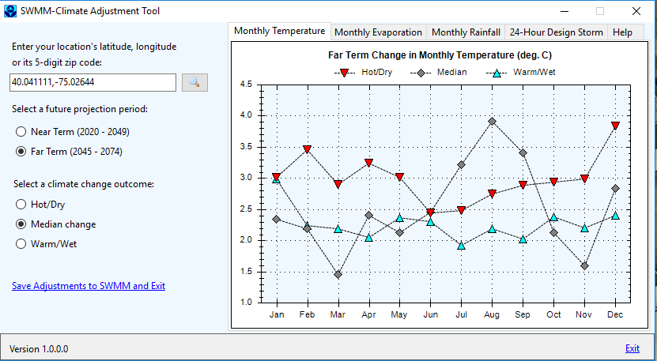

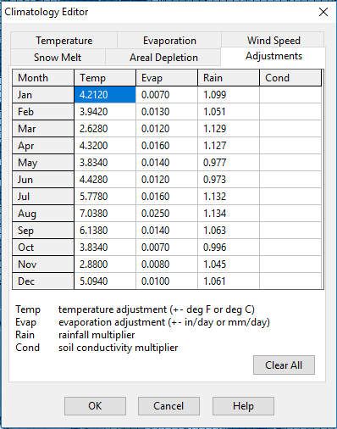

Deliverable Set #3

|  |  |  |  |  |  |  |  |  |  |  |  |  |
| --- | --- | --- | --- | --- | --- | --- | --- | --- | --- | --- | --- | --- |
| Summary Report Results | Init. LID Storage | | Precipitation | | Evaporation | | Infiltration | | Runoff | | Final Storage | |
| ac-ft | in | ac-ft | in | ac-ft | in | ac-ft | in | ac-ft | in | ac-ft | in |
| Baseline Condition | -- | -- | 29.6 | 43.96 | 3.891 | 5.779 | 4.652 | 6.909 | 21.06 | 31.277 | 0 | 0 |
| Proposed Condition | 0.082 | 0.122 | 29.6 | 43.96 | 5.431 | 8.065 | 8.218 | 12.21 | 15.781 | 23.437 | 0.256 | 0.38 |
| Baseline Condition, CAT | -- | -- | 31.6 | 46.931 | 4.129 | 6.133 | 4.958 | 7.363 | 22.517 | 33.441 | 0 | 0 |
| Proposed Condition, CAT | 0.082 | 0.122 | 31.6 | 46.931 | 5.847 | 8.683 | 8.707 | 12.932 | 16.878 | 25.066 | 0.254 | 0.377 |